Eco-driving for developing cities
By Thirayoot Limanond
Many countries are exploring various alternatives to reduce fuel consumption and preserve air quality in urban areas. There is a variety of attractive measures, such as promoting public transit and bicycle use, deploying congestion pricing or fuel taxes, etc, which have been proven successful in the past. Another measure is applying the concept of Eco-driving, a simple, low-cost, yet effective approach to save fuel and preserve the environment. Previous implementations have demonstrated that simply changing driving style can save fuel consumption and CO2 emissions as much as 7 -20%.
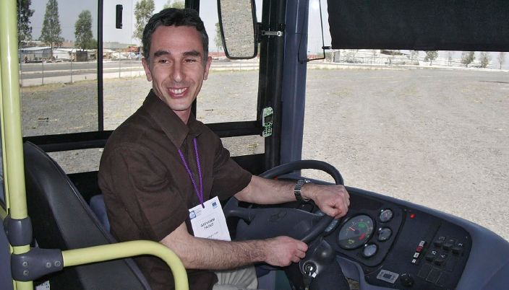
Eco-driving (from the longer term “economical and defensive driving”) is a style of driving that saves energy consumption, reduces air pollution emission and creates safe and relaxed driving atmosphere. It involves a number of activities that begin even before a driver turns on the engine, including route planning and basic vehicle checks. These driving techniques are most successful and effective when applied to public transport vehicles and fleets in operation as explained below. During the trip, there are some key driving tips to be considered:
- prior to starting the trip, allow the engine to run at a moderate speed (run gently) until the engine is warmed up.
- drive at a constant speed as much as possible; avoid rapid acceleration and abrupt deceleration.
- changing gears at appropriate times.
- wherever appropriate, use the engine for deceleration.
- switch off the engine when the vehicle is stationary for more than half a minute.
- drive anticipating how other travelers will react to road and traffic conditions.
The implementation of Eco-driving will yield benefits not only to vehicle drivers, but to businesses and to society as well. For individual drivers, driving economically will reduce spending on fuel and repairs/maintenance. Furthermore, drivers will be less stressed, less exhausted, and less prone to being involved in car accidents.
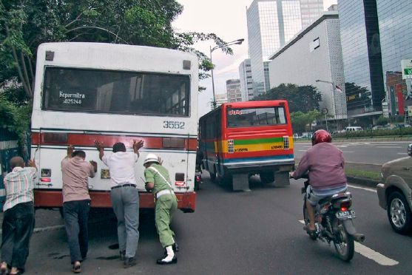
For public transport and logistic businesses that operate large vehicle fleets, training and monitoring company drivers to drive economically will ensure savings in fleet operating costs by reducing expenses on fuel, tires, and maintenance. It will also minimize the risk of downtimes. As a result, good driving records may also lower premiums on fleet vehicle insurance.
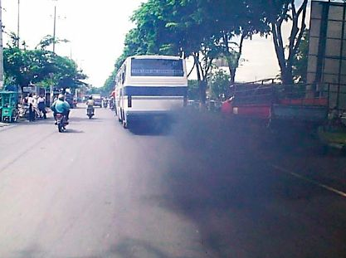
Benefits of eco-driving to society include the following: First, eco-driving will lead to less fuel consumption. Driving economically leads also to less emissions of air pollutants, which would improve air quality in urban areas and at the same time will reduce global CO2 emissions. This will contribute to cleaner air and will help improving quality of life. . It would also reduce citizens’ morbidity and mortality rate, helping reducing productivity losses due to health problems. Lastly, the city streets will become safer due to fewer accidents.
Interestingly, Eco-driving is an alternative that does not require significant investments; it only needs educational programs, and if possible a strategic monitoring or enforcement system. Thus, it is considered one of the most cost-effective approaches to reduce fuel consumption and improve air quality.
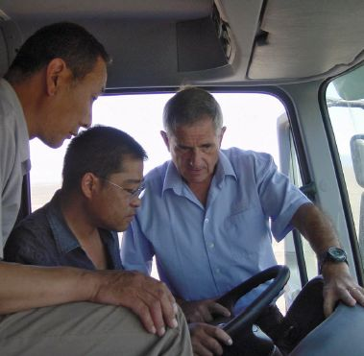
Training courses in Eco-driving are popular in Europe, North America, New Zealand, Australia, and increasingly in Asia as well. No wonder, since they provide win-win solutions. Such training courses had achieved impressive results. For example, GTZ conducted a series of training courses in Buenos Aires, which resulted in an average14.2 percent saving in fuel costs among participants. Similarly, training courses were offered in Jakarta and Surabaya for bus drivers and achieved 7-15% of energy saving. The costs for such courses are amortized in a short while by resulting fuel savings. There are many more successful examples and interesting information that readers can find in the GTZ module 4f, titled EcoDriving (downloadable free of charge from www.sutp.org). In addition, SUTP can provide further information for policy makers and public transport companies who are interested to arrange Eco-driving training courses in their cities.

